**Factors Affecting the Salary of an employee**

By

**Shaik Sumavarsha**

M00318018

**CIS 663**

Spring 2022

Master of Science in Information Systems (MSIS) Program

**Introduction**

The Factors Affecting the Salary of an employee can be defined as, the conditions like job position, education, industry, department, and more. People can improve the salary of an employee by keeping their skill upgraded. If they have an idea about salary factors, then they can apply those ideas in the actual job and they can get a better pay for their employees. There is a need to mention that the salary of an employee depends on people’s company’s growth, financial stability, and the performance of the employees in the company. The salary of an employee is not always the same, there are some factors that can be considered to increase the salary of an employee (Belete et al., 2018). The factors that can be mentioned here are as follows:

**Education level:**

If people have a higher level of education, then their employment will give them a better salary. They can get a better pay by improving their skill level and their qualification will also increase their salary. People will get a good pay by getting the diploma from a professional institute, by gaining certificate from the company, and by adding an online course and earning the degree and this will give them a good salary.

**Experience:**

The more experience an employee has the better pay they will receive. If they are working in a company for a long time, then they will receive a good pay, because they will know the importance of time and more experience, they will have more authority in the organization. If their experience is a short period of time, then they should join the company and learn from the mistakes of other employees and learn new knowledge and experience will boost their salary.

**Company’s growth and financial stability:**

The company that people are working in is the key factor for increasing the salary of an employee, because if the company is growing then their employee will get a good salary and if the company is not growing then the salary of an employee will not be good. The company’s financial stability will be dependent on the number of clients, their salary, and the cost of the company. If the company is profitable and growing, then it will support the salary and financial burden will be lower (Belete et al., 2018).

**Problem Statement**

The gender pay space is the distinction among common pay for guys and common pay for women in a particular company or commercial enterprise environment. An ‘averaging’ approach is commonly used. This is the maximum famous manner to degree the gender pay space, as it permits for the evaluation of all personnel, no matter whether or not they work full-time or part-time, or in exceptional businesses, or are personnel of various sorts of employers. The ‘averaging’ approach is a greater complete manner of measuring the gender pay space, as it takes under consideration the income of various sorts of personnel, and consists of the income of part-time workers.

The lifestyles of a gender pay space is at once related to gender discrimination, or how women and men are handled via way of means of employers, mainly as a way as their income are concerned. The gender pay hole is frequently visible due to factors

**Inequality at the manufactory**

The inequality at the manufactory between men and women can be defined as the level at which the wages paid by the man are enough to pay his full cost of reproduction, leaving him, therefore, with an income exceeding his wage. The basic idea is that the woman who is to be paid what is considered by her to be a wage, the wage for a man is high enough so that it is possible for her to have a child for a certain wage. If the wage is not high enough, the woman will be unable to have the child she desires. The wage that gives the best chances for the production of the desired number of children is equal to one fourth of the cost of reproduction of the man. The wage is the level at which the man could afford to raise the number of his children at the optimal level. The wage for the woman is one fourth of the wage paid by the man. This is true for the wage needed for each child, as well as for the total costs (Belete et al., 2018).

**Gender Typecast**

The gender typecast can be defined as gender where there is a lack of awareness of what the person really is beyond the gender binary. To break the gender typecast, one must be aware of the various forms of non-cisgender gender, which include transsexual, genderqueer, poly-gender, androgynous, transgender, agender, genderfluid, neopronoun, gender-neutral, pangender, androgynous. As a child growing up, most people would probably have had very little to no experience with gender-variant children. As an adult who is in school, one may be shocked to find many kids in school who would fit into these gender-variant categories (Belete et al., 2018).

The Fair Work Commission has additionally tried to make modifications to the system, via way of means of ordering employers to study the pay in their workers. These modifications have been introduced approximately via way of means of a developing wide variety of instances of salary discrimination, and the Commission commenced to reserve employers to study the profits systems that they have been paying, and to make modifications in which necessary. It is extraordinarily vital that everyone employers take a look at same pay legislation, and they supply same pay to personnel who do the equal paintings. However, it's far frequently hard for personnel to show that their paintings have now no longer been same to that in their male colleagues, so groups need to attempt to justify their unequal pay systems.

**Literature Review**

According to the survey with the aid of using Amanda Barroso and Anna Brown, it has determined that a majority of US personnel, 61 percentage, assume there's a pay hole withinside the U.S. and that girls are underpaid as compared to guys. Nearly 1 / 4 of personnel, or 24 percentage, say they consider there's no hole in pay among genders. Meanwhile, 8 percentage of respondents, or about 2.2 million workers, are unsure. The survey additionally determined that 56 percentage of personnel consider that at the same time as women make much less than men, they nonetheless carry out in addition to their male counterparts, that's the notion that the gender pay space is a myth. However, while requested in the event that they assume that males and females ought to be paid similarly or if men ought to be paid greater than women, 46 percentage stated men ought to be paid greater and best 16 percentage stated that males and females ought to be paid similarly. Another 19 percentage weren’t positive if men or women ought to be paid greater (Barroso & Brown, 2021).

According to the Janelle Jones, the 5 facts about the state of the gender pay gap in U.S. are: A) Pay gap isn’t just a gap: This sounds like it might be a really easy point to get across: the pay gap between men and women is about average, with men earning about 1.6 to 1.8 times more than women on average. However, the fact is that this only captures a small segment of the pay gap—those women who make less than men make the exact same on average, but this is because there are a lot more women than men with that kind of pay. B) There are a lot more women than men: There are about three times more women than men in the country. The gap is smaller for those who are older, and increases for those who are young. Still, it’s huge. The gap is only about 70 percent in the country, but it’s about 20 percent in the workforce. C) Women make more than men in the high-earning brackets: There is a pay gap in pay for men and women that’s true for the population, but that is largely reflected by a pay gap for men and women in the lower-paid brackets, not the higher-paid brackets. This makes sense: women who don’t make very much don’t make as much as men who don’t make very much. That’s the reason that the gender pay gap for college graduates goes away in the first place: men and women with college degrees make the same on average. D) Experience matters: The point of the first fact was to point out that experience is what matters. The fact is that women are not only paid less than men, they are also paid less than men who are at the same level of education and experience. E) Pay isn’t everything: The next fact in the post is that it’s only about pay. This is especially important for women who are paid less than men for the same amount of education and experience. In other words, in the United States, women who are paid more than men for the same amount of experience and education (for example, tenured positions in academia) are also more likely to have children. They are also more likely to go into another career at some point (Janelle Jones, 2019).

**Research Questions**

* What factors affect the salary of the employee?
* What if the factors have a significant relationship with a high pay?

**Data**

The data for the Factors Affecting the Salary of an employee will be collected from any random organization in each country. These organizations will be chosen randomly and without

any bias and no consent is required. The companies selected are to be in each country to ensure that the questionnaire is a true representation of the country's industry. Factors affecting the salary of an employee in the workplace are categorized as organizational, professional, and personal factors. Organizations have been defined as the main unit of analysis and measurement. The organizational factors are also commonly referred to as job factors. Therefore, some researchers have used the terms job factors or job-related factors interchangeably. Organizational job factors are typically considered to be the characteristics of the employee. The common characteristics of organizational job factors include the type of job, employment level, the type of organization, and the position level. There are numerous factors that can affect an employee's job-related performance; however, several factors are important in determining the employee's salary. According to the literature, among the important factors, the organization plays a major role in the salary of an employee in the workplace (Grishnova et al., 2019).

**Methodology**

The statistics may be imported to R and the statistics may be checked if there are any lacking fields are gift and statistics cleansing may be carried out if necessary. After the statistics cleansing technique is carried out, Income, I will locate the correlation among the variables and locate the elements that have an effect on the earnings of many of the genders. Also locating if there's any tremendous dating many of the variables in predicting the month-to-month profits of a person are utilized. The second part of the study analyzes a series of choices that have been made by various individuals in the course of their lives, and tries to predict, for example, what choices were more probable to result in achievement. After the technique of the analysis is carried out, then the variables which impact a larger quantity of individuals will be identified.

In reality, many people are not as enthusiastic about data cleansing as other folks are, so there’s an important necessity to know the difference between cleaning and cleansing (Hitka et al., 2018).

The methodology for the factors affecting the salary of an employee can be defined as a set of guidelines, best practices, rules of thumb or theories that will be applied by an organization to the process of deciding how much money to give to each of their workers. When it comes to how the organization perceives the role of the employees and their responsibilities, their job or occupation, etc., factors can vary from one organization to another. There is a theory that states that an experienced employee makes more money than an inexperienced employee. Some organizations use the experience to explain the factors that affect the salary of the employees in order to make the compensation and benefits package more attractive and desirable for the applicants. This theory is the reason why employers give new employees less pay in the beginning. Usually, it is to allow them to learn about their responsibilities and how their work will be rewarded (Hung et al., 2018).

**Visual Representation**

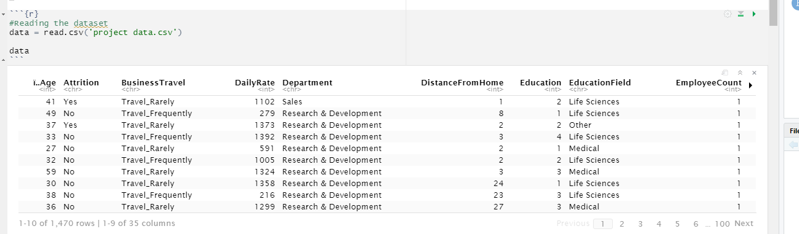

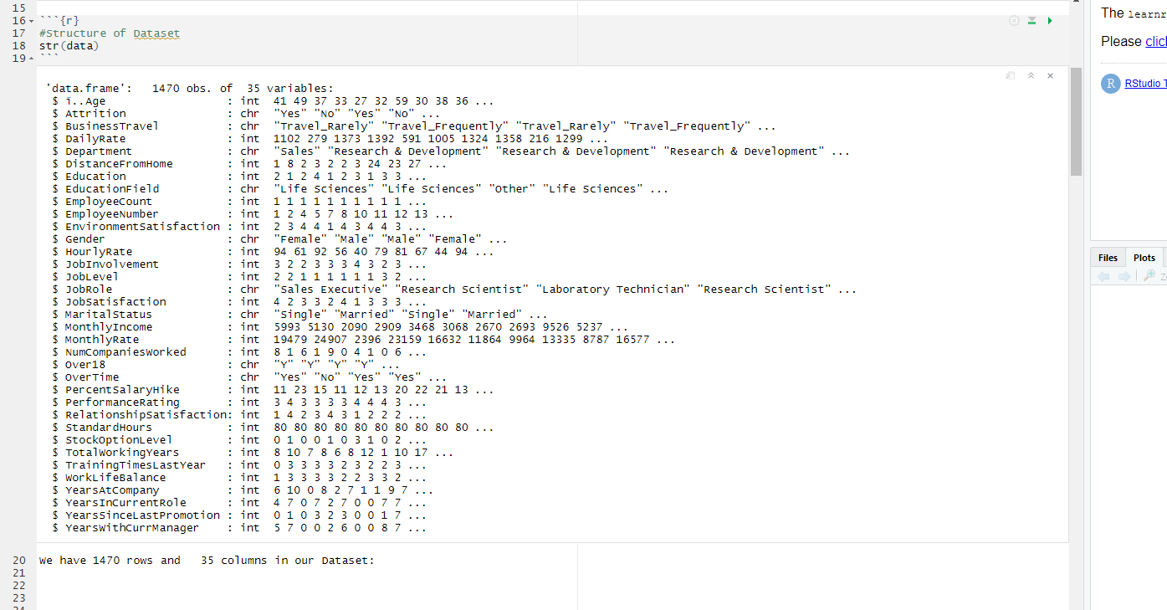

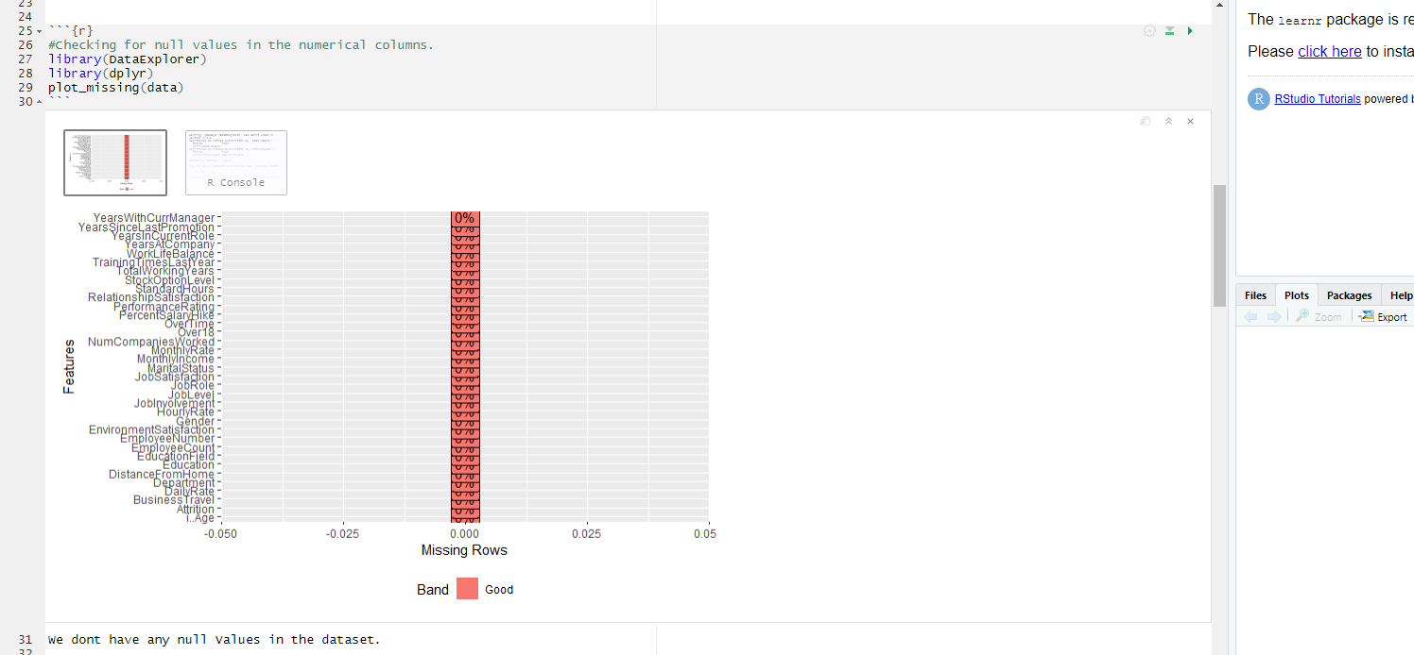

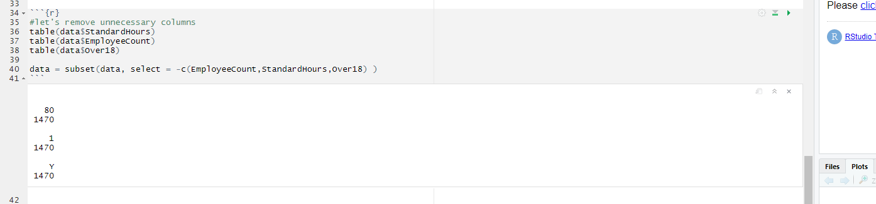

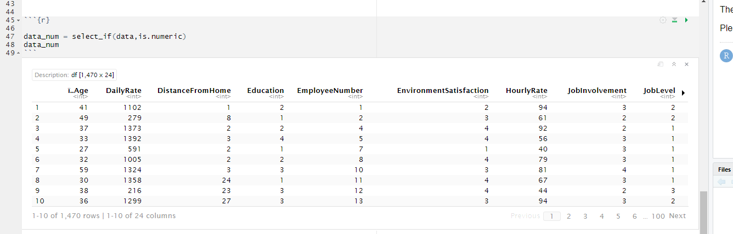

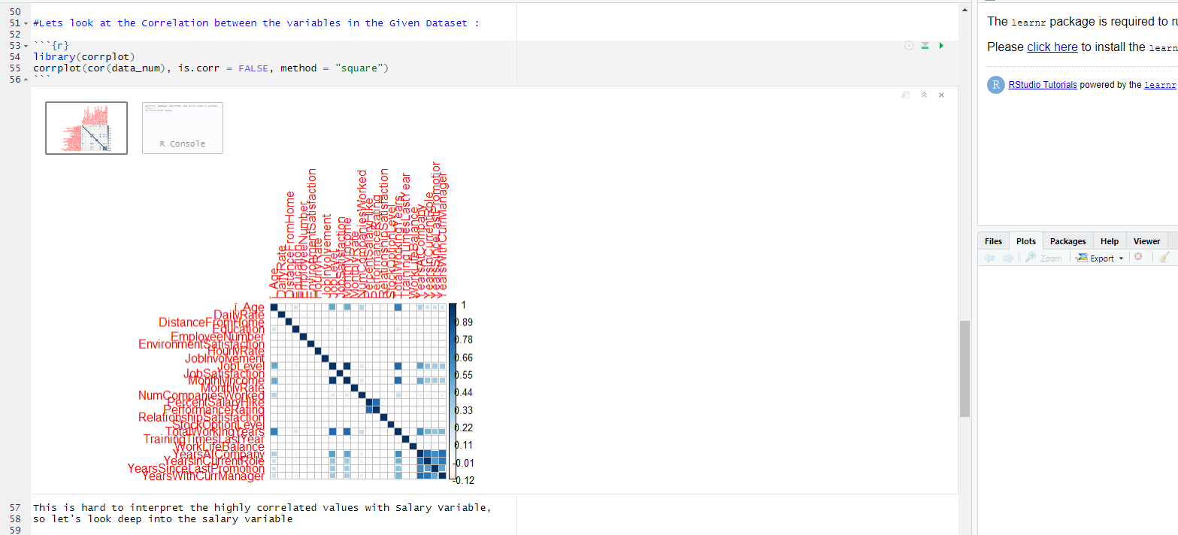

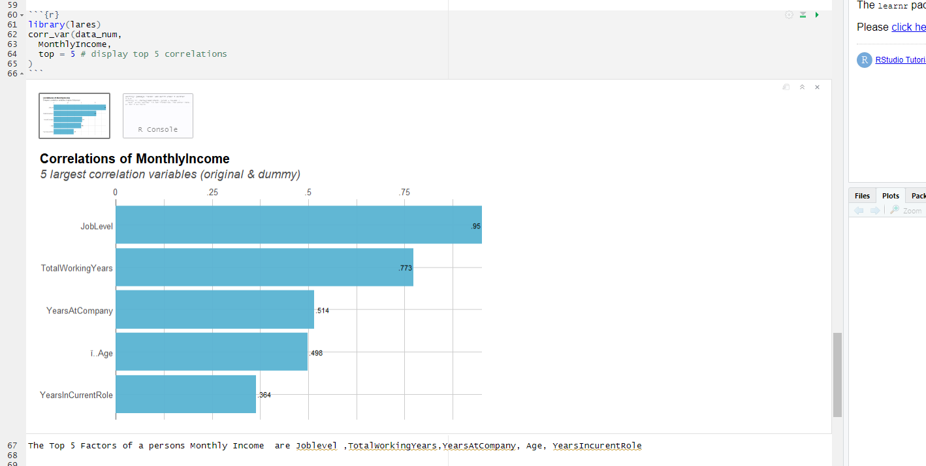

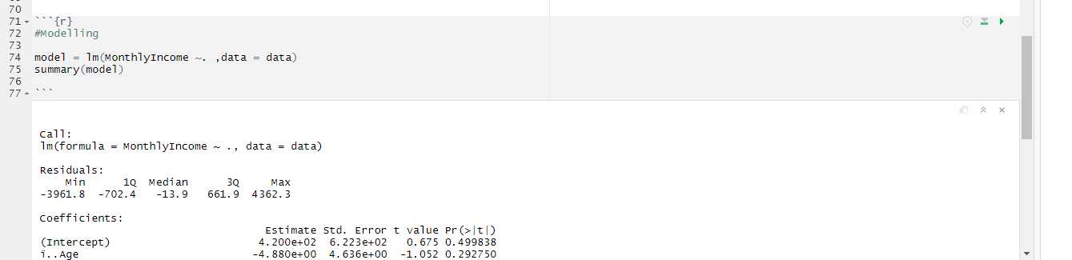

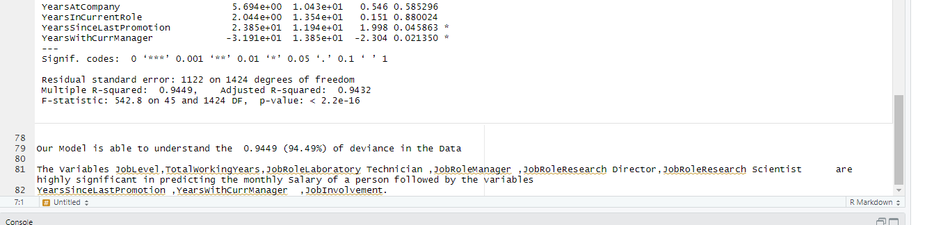

**Conclusion**

In conclusion, the factors that most seems to affect employee’s compensation are: The length of the employee's service, whether the employee has been on duty continuously for a specified period and whether the employee's performance has been evaluated in accordance with procedures established by the employer. Whether the employee has been granted leave to work or is under a temporary, reasonable, or continuous general disability of an ordinary person. There are many factors that affect the salary of an employee and it is not always about money. Some factors such as industry and industry-specific skills and training, experience, age and previous experience are associated with higher salaries. Other factors, such as experience, culture, working conditions, and a variety of other factors can all have an impact (Hung et al., 2018), for example there are also several external factors that affect the employees pay, like cost of living, labor laws, the industry specific laws and many more which we are unable to count for in this research and it would be an interesting point to research the external factors as well and compare both the internal and external factors to determine which factors when compared, has the most effect on compensation.

**References**

Belete, A. K. (2018). Turnover intention influencing factors of employees: an empirical work review. Journal of Entrepreneurship & Organization Management, 7(3), 1-7.

Barroso, A., & Brown, A. (2021, May 25). Gender pay gap in U.S. held steady in 2020. Pew Research Center. Retrieved from <https://www.pewresearch.org/fact-tank/2021/05/25/gender-pay-gap-facts/>

Grishnova, O., Cherkasov, A., Brintseva, O., Sakovska, O., & Ostapchuk, A. (2019). Transition to a New Economy: Transformation Trends in the Fields of Income and Salary Functions. In SHS Web of Conferences (Vol. 67, p. 06019). EDP Sciences.

|  |
| --- |
|  |

Hitka, M., Kozubíková, Ľ., & Potkány, M. (2018). Education and gender-based differences in employee motivation. Journal of Business Economics and Management, 19(1), 80-95.

Hung, L. M., Lee, Y. S., & Lee, D. C. (2018). THE MODERATING EFFECTS OF SALARY SATISFACTION AND WORKING PRESSURE ON THE ORGANIZATIONAL CLIMATE, ORGANIZATIONAL COMMITMENT TO TURNOVER INTENTION. International Journal of Business & Society, 19(1).

Janelle Jones. (2021, March 19). 5 facts about the state of the gender pay gap. United States Department of Labor. (n.d.). Retrieved from <https://blog.dol.gov/2021/03/19/5-facts-about-the-state-of-the-gender-pay-gap>